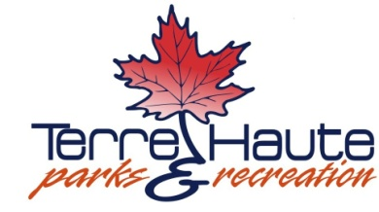

Park Board Meeting
Wednesday, February 20, 2019
4:30pm
Torner Center

1. Call to Order

2. Welcoming Remarks

3. Approve Claims, Payroll and Minutes

4. Old Business
a. Master Plan
b. RD Productions

5. New Business
a. Men of Note Agreement
b. Assistant Recreation Director/Recreation Maintenance
c. John Dice Agreement

6. Announcements /Park Superintendent/Park Board

7. Public comment on non-agenda items – (limited to 5 minutes)

9. Adjournment

Next Meeting
March 20, 2019
4:30 pm
Torner Center

Any individual who requires an auxiliary aid or service for effective communication, or a modification of policies or procedures to participate in a public meeting, program, service, or activity of the City of Terre Haute, should contact Melissa Reed at the Human Relations Department, 17 Harding Ave, Terre Haute, IN 47807, (812) 244-5611, as soon as possible, but no later than 48 hours before the scheduled event.

