
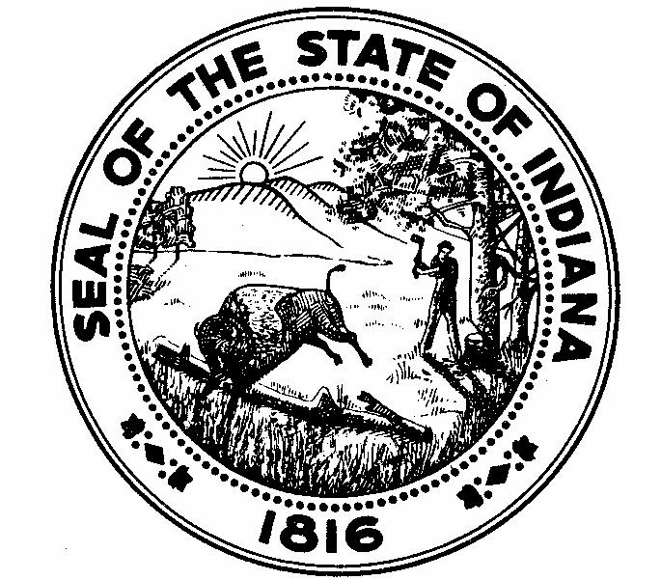
TERRY R. MODESITT
PROSECUTING ATTORNEY
OF VIGO COUNTY
VIGO COUNTY COURT HOUSE
33 SOUTH THIRD STREET, RM. 45
TERRE HAUTE, IN 47807
PHONE (812) 462-3305
FAX (812) 238-1096
July 1, 2024

To: All Vigo County Retailers with THC related products
From: Terry Modesitt, Vigo County Prosecutor
RE: THC products that are not low THC hemp products

Dear Retailer Owner/Operator/Manager:

It has come to our attention that you may have Delta 8, Delta 10, or other THC products that do not qualify as low THC hemp products available for sale at your place of business. As you likely are aware, the legality of these substances has been a discussion point for some time now for prosecutors and law enforcement across the state.

In 2023, the Indiana Attorney General’s Office issued an official opinion that Tetrahydrocannabinol Variants and Other Designer Cannabinoid products (which would include Delta 8, Delta 10 and other THC derivatives) DOES fall under the statutory definition of a Schedule I Controlled Substance. Therefore, I’m writing to inform you that if you continue to possess and/or sell those products, you (and/or your employees) could be charged with Dealing in a Controlled Substance under Indiana Code 35-48-4-2. Depending on the weight – that charge could be up to a Level 2 Felony which has the possibility of 10-30 years in prison.

In addition to the criminal charges, continuing to sell those products could also subject you to search warrants, subpoenas, forfeiture proceedings, and all other tools available under the law.

Another product you may have on your shelves is smokeable hemp. It is also not legal in Indiana under I.C. 35-48-4-10.1. There is, as you may know, an exception in the law for CBD products with less than 0.3% THC. That does not, however, include anything with THC that is smokable. Additionally, CBD products are within the definition of “Low THC hemp extract” under I.C. 35-48-1-17.5, which specifically excludes the flower or bud.

Finally, I.C. 35-48-4-10(d)(3) includes a Level 5 Felony for a retailer to sell anything they knew or should have known contains more than 0.3% Delta 9 THC packaged as low THC hemp extract. Please know that a recent investigation into products sold by retailers in this county that claim to have less than 0.3% Delta 9 THC were found during testing through the Indiana State Police lab to have levels of THC significantly in excess of this amount even though the packaging on the product claims to be less than 0.3% Delta 9 THC and supporting documents from the distributor claim to have had the product tested.

So again, if you are selling either of those products – and continue to – you are risking legal action from law enforcement and my office. The best course of action is to immediately remove all Delta 8, Delta 9, Delta 10, Delta X (and any other designer cannabinoid products) and Smokeable Hemp products from your shelves and do not sell or use them in the future.

Feel free to contact my Chief Deputy Prosecutor, Rob Roberts, with further questions.

Sincerely,
/s/ Terry R. Modesitt
Prosecuting Attorney, Vigo County, Indiana

Attachment: Official Opinion 2023-1 from the Attorney Gene

